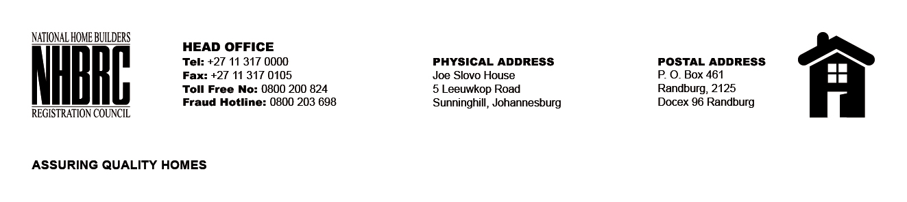

OPENING REGISTER
BID NUMBER : NHBRC 03/2023_Polokwane
CLOSING DATE : 25 August 2023 @ 11H00

BID DESCRIPTION: APPOINTMENT OF A SERVICE PROVIDER TO PROVIDE
SUITABLE OFFICE ACCOMMODATION AND PARKING FACILITIES FOR POLOKWANE
OFFICE FOR A LEASE PERIOD OF NINE (09) YEARS, ELEVEN (11) MONTHS

NO. | NAME OF BIDDERS | TOTAL BID PRICE (INCL. VAT)
1. | Columbia Falls Properties 80 (Pty) Ltd | R 23 164 930.83
2. | Emmunah Real Estate | R 22 725 542.00
3. | Lebombo Bellegings | R 27 789 166.80
Total 03 Bids

