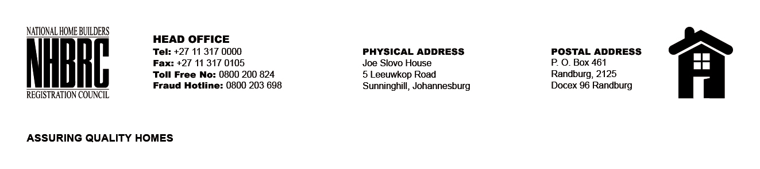

BID NUMBER: NHBRC 04/2023
CLOSING DATE: 15 AUGUST 2023 @ 11H00

BID DESCRIPTION: REQUEST FOR PROPOSALS: APPOINTMENT OF A PANEL OF INTERNAL AUDITORS TO THE NATIONAL HOME BUILDERS REGISTRATION COUNCIL (“NHBRC”) FOR A PERIOD OF THREE (03) YEARS. FREE STATE (BLOEMFONTEIN)

NO. | NAME OF BIDDER | PRICE (INCLUDING VAT)
1. | NOLANDS ADVISORY SERVICES BFN (PTY) LTD | PER AG RATES
2. | CHAPU CHARTERED ACCOUNTANTS INC
3. | PWC
4. | SAB &T CHARTERED ACCOUNTANTS INCORPORATED
5. | SNG GRANT THORNTON
6. | RAKOMA AND ASSOCIATES INC
7. | SAMBA SOLUTIONS INC
8. | MOSEGARE AND ASSOCIATES INCORPORATED
TOTAL: 08

