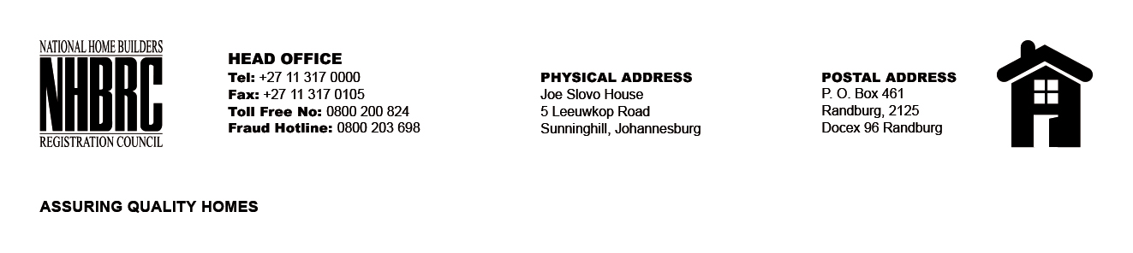

BID NUMBER: NHBRC 04/2023
CLOSING DATE: 16 AUGUST 2023 @ 11H00

BID DESCRIPTION: REQUEST FOR PROPOSALS: APPOINTMENT OF A PANEL OF INTERNAL AUDITORS TO THE NATIONAL HOME BUILDERS REGISTRATION COUNCIL (“NHBRC”) FOR A PERIOD OF THREE (03) YEARS. WESTERN CAPE (CAPE TOWN)

NO. | NAME OF BIDDER | PRICE (INCLUDING VAT)
1. | SAB &T CHARTERED ACCOUNTANTS INCORPORATED INC | PER AG RATES
2. | HARVEST CHARTERED ACCOUNTANTS INC
3. | SNG GRANT THORNTON
4. | PANDELL CONSULTING
5. | SAMBA SOLUTIONS INC
TOTAL: 05

