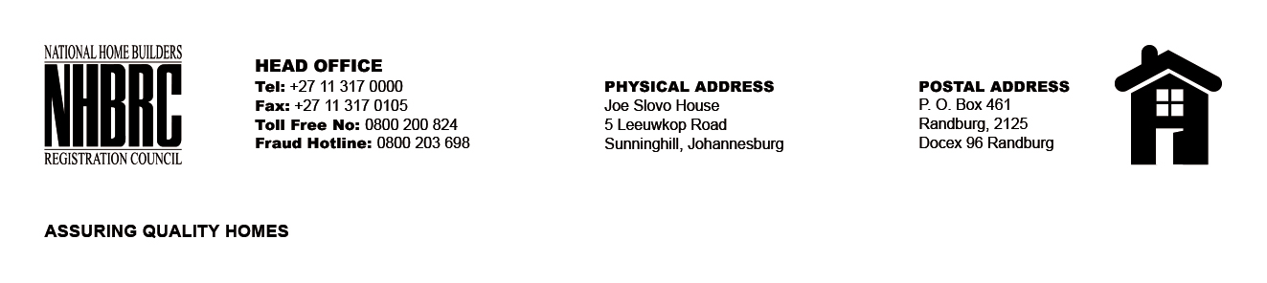

OPENING REGISTER

BID NUMBER : NHBRC 03/2023_EC East London
CLOSING DATE : 10 October 2023 @ 11h00

BID DESCRIPTION: REQUEST FOR PROPOSALS: APPOINTMENT OF A SERVICE
PROVIDE TO PROVIDE SUITABLE OFFICE ACCOMMODATION AND PARKING
FACILITIES FOR THE EAST LOND OFFICE FOR A LEASE PERIOD OF FIVE (05) YEARS.

NO. | NAME OF BIDDERS | PRICE (INCL. VAT)
1. | SKG Africa (Pty) Ltd | R4 486 775.30  R4 507 266.50
TOTAL BIDS RECEIVED |  | 01

