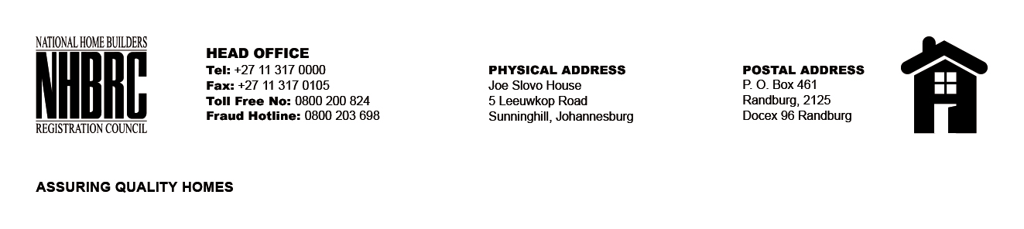

OPENING REGISTER

BID NUMBER : NHBRC 01/2022: (Mpumalanga)
CLOSING DATE : 13 April 2023 @ 11H00

BID DESCRIPTION: APPOINTMENT OF A PANEL FOR THE DESIGN, SUPPLY, AND INSTALLATION OF PROJECT (CONSTRUCTION) SIGNAGE BOARDS FOR A PERIOD OF THREE YEARS.

NO. | NAME OF BIDDERS
1. | Procost And Associates (Pty) Ltd
2. | Nano Holdings (PTY) LTD
3. | Maxaca Printers
4. | Siphosethu Printing x Projects
5. | Zane Siba Trading and Projects (Pty) Ltd
Total 5 Bids

