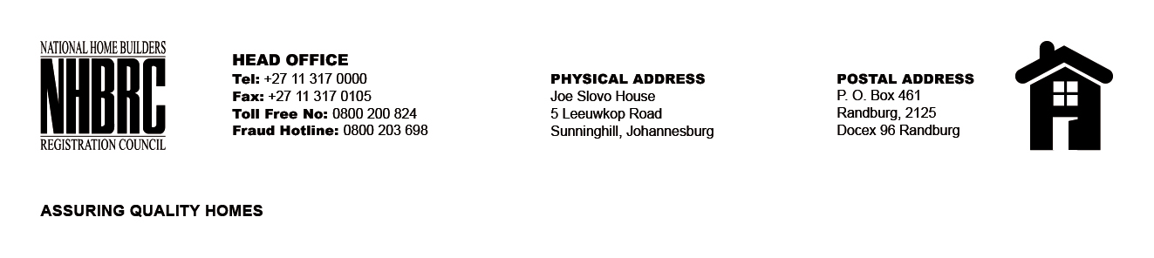

OPENING REGISTER
BID NUMBER : NHBRC 03/2023: NW Rustenburg
CLOSING DATE : 10 October 2023 @ 11H00

BID DESCRIPTION: APPOINTMENT OF A SERVICE PROVIDER TO PROVIDE
SUITABLE OFFICE ACCOMMODATION AND PARKING FACILITIES FOR THE RUSTENBURG
OFFICE FOR A LEASE PERIOD OF NINE (09) YEARS, ELEVEN (11) MONTHS

NO. | NAME OF BIDDERS | TOTAL BID PRICE (INCL. VAT)
1. | New Heights 480 (Pty) LTD | R 6 258 652.90
Total 01 Bids

