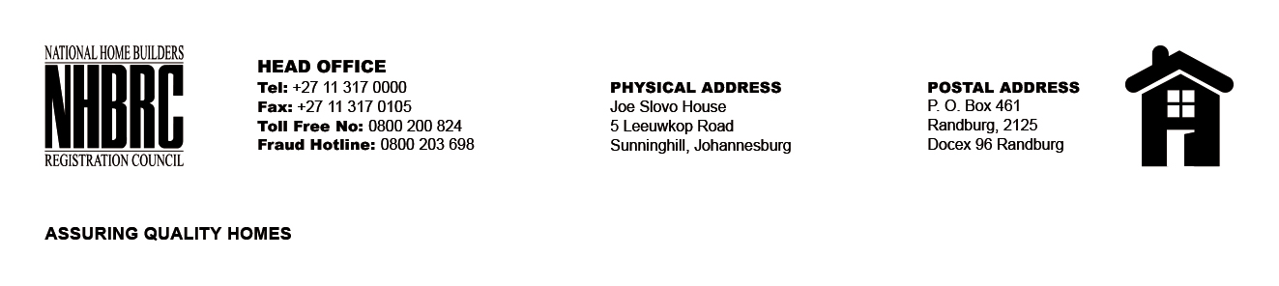

OPENING REGISTER

BID NUMBER : NHBRC 01/2023: KZN DURBAN
CLOSING DATE : 25 July 2023 @ 11H00

BID DESCRIPTION: APPOINTMENT TO THE NATIONAL HOME BUILDERS REGISTRATION COUNCIL’S (“NHBRC”) PANEL OF ATTORNEYS FOR A PERIOD OF FIVE (05) YEARS.

NO. | NAME OF BIDDERS
1. | MS MSIBI ATTORNEYS INC
2. | TALENI GODI KUPISO INC
3. | NKOSI SABELO INC
4. | MPANZA & ASSOCIATES
5. | FREEDOM & ASSOCIATES
6. | FARRELL INC. ATTORNEYS
7. | MATTHEW FRANCIS INC.
8. | DM5 INCORPORATED
9. | MAZIBUKO Z & ASSOCIATES
10. | MACROBERT ATTORNEYS
11. | MIYA ATTORNEYS
12. | MADLANGA PARTNERS INC ATTORNEYS
13. | NGWANASE – TEMBE INC
14. | MCHUNU ATTORNEYS
15. | PATHER & PATHER
16. | TENG HUNG – HAN INC.
17. | DUVENAGE ATTORNEYS PROKUREURS
18. | PUMLA NKOSI ATTORNEYS
19. | PRAVINA GOVENDER ATTORNEYS
20. | MBOWENI AND PARTNERS INC.
21. | MADIBA MOTSAI MASITENYANE & GITHIRI
22. | COWAN HARPER- MADIKIZELA
23. | L GUZANA INC
24. | SM VAKULISA INC
25. | C MABUNDA INC
26. | K GCOLOKELA & PETER INC
Total 26 Bids

