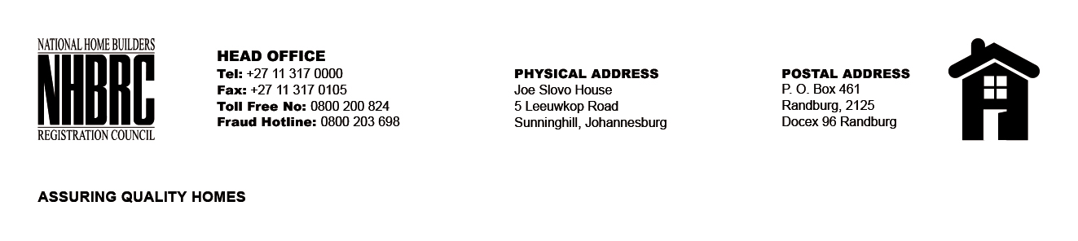

BID NUMBER: NHBRC 10/2023
CLOSING DATE: 25 JANUARY 2024 @ 11H00

BID DESCRIPTION: REQUEST FOR PROPOSALS: ESTABLISHMENT OF A PANEL OF SERVICE PROVIDERS TO PERFORM CONSTRUCTION MATERIAL TESTING SERVICE TO NHBRC FOR A PERIOD OF FIVE (5) YEARS

NO. | NAME OF BIDDER
1. | STEYN WILSON LABORATORIES
2. | ROAD LAB LABORATORIES (PTY) LTD
TOTAL: 2

