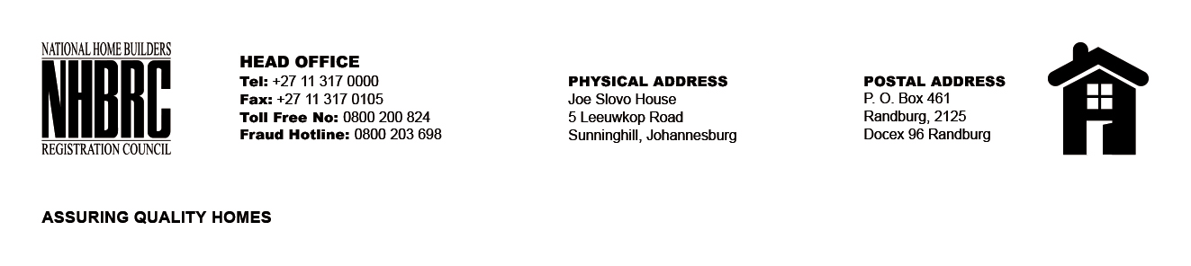

BID NUMBER: NHBRC 10/2023
CLOSING DATE: 23 JANUARY 2024 @ 11H00

BID DESCRIPTION: REQUEST FOR PROPOSALS: APPOINTMENT OF A PANEL OF SERVICE PROVIDERS TO PERFORM CONSTRUCTION MATERIAL TESTING SERVICE TO FOR A PERIOD OF FIVE (5) YEARS

NO. | NAME OF BIDDER
TOTAL: 0

