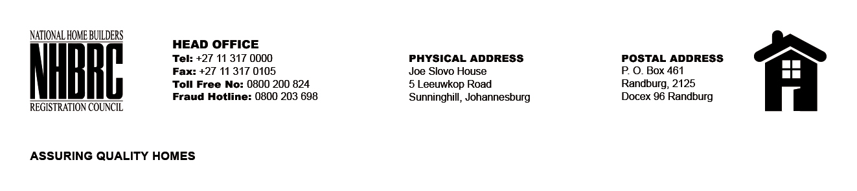

BID NUMBER: NHBRC 08/2023
CLOSING DATE: 26 January 2024 @ 11H00

BID DESCRIPTION: REQUEST FOR PROPOSALS: APPOINTMENT OF A PANEL OF ASSET MANAGEMENT SERVICES TO THE NHBRC FOR A PERIOD OF THREE (3) YEARS

NO. | NAME OF BIDDER
1. | BENGUELA GLOBAL FUND MANAGERS (PTY) LTD
2. | SEFIKILE CAPITAL (PTY) LTD
3. | MIANZ ASSET MANAGEMENT (NO USB)
4. | TAQUANTA ASSET MANAGEMENT (PTY) LTD
5. | OLDMUTUAL INVESTMENT GROUP
6. | TEREBINTH CAPITAL
7. | STEYN CAPITAL MANAGEMENT
8. | BLUE ALPHA INVESTMENT MANAGEMENT
9. | DIFFERENTIAL CAPITAL
10. | CORONATION ASSET MANAGEMENT (PTY) LTD
11. | LEGACY AFRICA FUND MANAGERS
12. | EXCELSIA CAPITAL
13. | VUNANI FUND MANAGERS
14. | CAMISSA ASSET MANAGEMENT
15. | EFFECTUS CAPITAL MANAGEMENT (PTY) LTD
16. | RETIREMENT INVESTMENT & SAVINGS FOR EVERYONE (RISE)
17. | MAZI
18. | LODESTAR FUND MANAGERS
19. | 27FOUR INVESTMENT MANAGERS (PTY) LTD
20. | AEON INVESTMENT MANAGEMENT
21. | PERPETUA INVESTMENT MANAGERS
22. | NINETYONE
23. | ALL WEATHER INVESTING IN POSITIVE OUTCOMES
24. | MSM PROPERTY FUND
25. | PRESCIENT INVESTMENT MANAGEMENT
26. | ASHBURTON INVESTMENTS
27. | MERGENCE INVESTMENT MANAGERS
28. | M & G INVESTMENTS
TOTAL: 28

