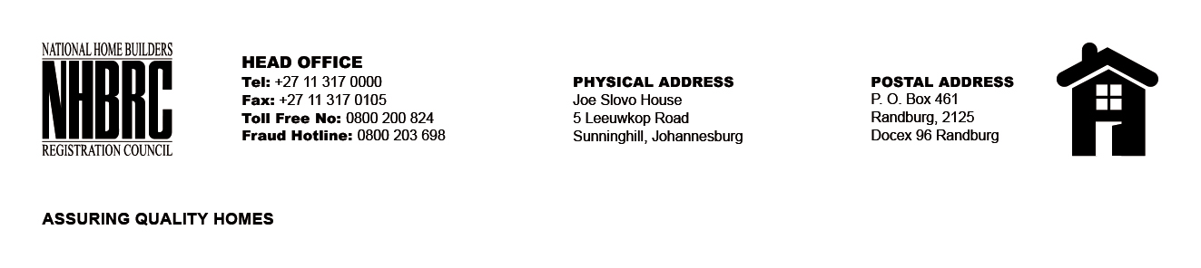

BID NUMBER: NHBRC 09/2023
CLOSING DATE: 29 January 2024 @ 11H00

BID DESCRIPTION: REQUEST FOR PROPOSALS: APPOINTMENT OF A SUITABLE SERVICE PROVIDER TO PROVIDE CLEANING SERVICES TO THE NHBRC HEAD OFFICE FOR A PERIOD OF THREE (3) YEARS

NO. | NAME OF BIDDER
1. | KGOMATSWE INVESTMENTS
2. | MABOKA CLEANING SERVICE
3. | POWER FULL CLEANING & PROJECTS (PTY) LTD
4. | BELLA VENTURE HOLDINGS
5. | CLEANING AFRICA SERVICES (PTY0 LTD
6. | KABELA TRADING CC
7. | THAAI SECURITY SOLUTIONS (PTY) LTD
8. | NELEDZI CLEANING SERVICES (PTY) LTD
9. | BLUE BREEZE CLEANING SERVICES (PTY) LTD
10. | TIKEDI HOLDINGS (PTY) LTD
11. | ADVANTAGE SECURITY AND CLEANING SERVICES
12. | KEMPSTON CLEANING SOLUTIONS
13. | KOLAGRA CLEANING SOLUTION
14. | DIKAPI CLEANING SERVICES (PTY) LTD
15. | IMANI BUSINESS ENTERPRISE (PTY) LTD
16. | REL COMMERCIAL AND RESIDENTIAL CLEANING SERVICES
17. | KAMESO TOTAL HYGIENE SERVICES
18. | MURANGI CLEANING AND MAINTENANCE (PTY) LTD
19. | IFM SOLUTIONS
20. | SIYANQOBA GENERAL ENTERPRISES (PTY) LTD
21. | MOSADIKHUMO INVESTMENTS
22. | LEPRO CORPORATION CC
23. | BHUBA M MULTI TRADING ENTERPRISE
24. | MORENA CORPORATE SERVICES (PTY) LTD
25. | BIDVEST SERVICES (PTY) LTD/ BIDVEST PRESTIGE
26. | DENZHELASHU TRADING AND PROJECTS (PTY) LTD
27. | NGQUTURA TRANSPORT SERVICES
28. | M- JNR AND OLWETHU CONSULTING (PTY) LTD
29. | OKS INVESTMENT 2009
30. | FIVE STAR CLEANING SERVICES
31. | MASANA HYGIENE SERVICES (PTY) LTD
TOTAL: 31

