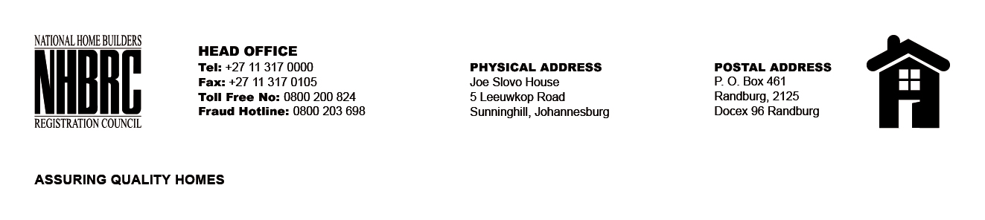

BID NUMBER: NHBRC 11/2023
CLOSING DATE: 31 January 2024 @ 11H00

BID DESCRIPTION: REQUEST FOR PROPOSALS: ESTABLISHMENT OF PANEL OF SERVICE PROVIDERS TO PERFORM RESIDENTIAL INSPECTORATE SERVICES ON BEHALF OF NHBRC FOR A PERIOD OF FIVE (5) YEARS.
GAUTENG (GP)

NO. | NAME OF BIDDER
1. | MIMISA ENGINEERING (PTY) LTD
2. | THAPELO TLHAPANE HOLDINGS (PTY) LTD
3. | NKHOPHELE HOLDINGS (PTY) LTD
4. | 02 M PROJECTS
5. | VHARANANI PROPERTIES (PTY) LTD
6. | E- SQUARE ENGINEERING (PTY) LTD
7. | DAUNEL PROPERTIES CC
8. | UMLONDOLZI (PTY) LTD
9. | KAGO BUILT ENVIRONMENT CONSULTANTS (PTY) LTD
10. | RAPAKATANI TRADING
11. | HAKHENSA CONSULTING
12. | JTP CONSORTIUM (PTY) LTD
13. | SEKOTHOBS
14. | TSEKE CONSTRUCTION CC
15. | DALMO AFRICA CONSULTING (PTY) LTD
16. | KRMS ARCHITECTS
17. | INHLAKANIPHO CONSULTANTS (PTY) LTD
18. | TKQ CONSULTING (PTY) LTD
19. | DDP VALUERS (PTY) LTD
20. | HI END GROUP
21. | TSEKWANE INVESTMENTS (PTY) LTD
22. | ISISEKO ENGINEERS
23. | UNDASA PROJECT PARTNERS
24. | JOBE GEOTECHNICAL SERVICES (PTY) LTD
25. | 690 SIGNATURE GROUP
26. | NGHUYUZA MASILANA ENGINEERING
27. | GLESH GROUP (PTY) LTD
28. | MPHATI AND ASSOCIATES (PTY) LTD
29. | DBI CONSULTING ENGINEERS
30. | TLOU TADIMA PROJECTS (PTY) LTD
31. | EXPLOSIVE STRUCTURAL ENGINEERS (PTY) LTD
32. | MAYISANE & ASSOCIATES ENGINEERING SOLUTIONS
33. | KABE CONSULTING ENGINEERS
34. | GUDUNKOMO INVESTMENTS AND CONSULTING
35. | RATZOE SOLUTIONS & PROJECTS (PTY) LTD
36. | EXILITE 349 CC
37. | GWACA CONSULTING
38. | AHANANG HARDWARE AND CONSTRUCTION (PTY) LTD
39. | JENDRA CAPITAL
40. | LUTENDO PROPERTY GROUP (PTY) LTD
41. | MGIBA CONSULTING
42. | THEMBAKELE CONSULTING ENGINEERS (PTY) LTD
43. | VIP CONSULTING ENGINEERS (PTY) LTD
44. | MARANJE CONSULTING
45. | PELOMON CIVIL & TRADING
46. | MANINGA ENGINEERING (PTY) LTD
47. | SERETO VENTURES CC
48. | C GIYOSE AND ASSOCIATES
49. | TN MOLEFE CONSULTING ENGINEERS (PTY) LTD
50. | OARONA CONSULTING & ENGINEERING (PTY) LTD
51. | VNMM HOLDING (PTY) LTD
52. | AKWENI GROUP PROPERTY SOLUTIONS
53. | MJT CONSULTING ENGINEERS 01 (PTY) LTD
54. | SKY HIGH CONSULTING ENGINEERS (PTY) LTD
55. | 2BLN ENGINEERING
56. | TLOU CONSULTING (PTY) LTD
57. | SHAWENI CONSULTING ENGINEERS (PTY) LTD
58. | CELANKOBE ENGINEERING & ARCHITECTURAL CONSULTANTS
59. | THATO NTSEKHE & ASSOCIATES (PTY) LTD
60. | ETILWENI (PTY) LTD
61. | PRANA CONSULTING (PTY) LTD
62. | V3 CONSULTING ENGINEERS (PTY) LTD
63. | KGALAWU CONSULTING
64. | NDLOVU NGONYAMA CONSULTING ENGINEERS (PTY) LTD
65. | MZANSI AFRICA CIVILS
66. | VUKA EMAQANDENI EMMAUS (PTY) LTD
TOTAL: 66

