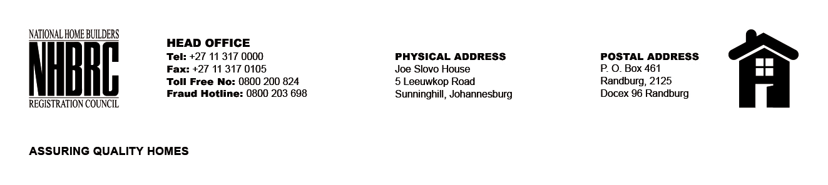

BID NUMBER: NHBRC 11/2023
CLOSING DATE: 05 FEBRUARY 2024 @ 11H00

BID DESCRIPTION: REQUEST FOR PROPOSALS: APPOINTMENT OF A PANEL OF SERVICE PROVIDERS TO PERFORM RESIDENTIAL INSPECTORATE ON BEHALF OF THE NHBRC FOR A PERIOD OF FIVE (5) YEARS
CAPE TOWN- WC

NO. | NAME OF BIDDER
1. | SHAWENI CONSULTING ENGINEERS
2. | LUTAK CONSULTING
3. | UNDASA PROJECT PARTNERS (PTY) LTD
4. | TECHQ & DEVELOPMENT (PTY) LTD
5. | THEMANE MANAGEMENT CONSULTING (PTY) LTD
6. | JTP CONSORTIUM
7. | V3 CONSULTING ENGINEERS
8. | TRIAKON ENGINEERING (PTY) LTD
9. | HLUMANTOMBAZANA CIVIL & CONSTRUCTION CC
10. | MJT CONSULTING ENGINEERS 01
11. | E-SQUARE ENGINEERING (PTY) LTD
12. | KATEMO GENERAL TRADING
13. | TTE GROUPS (PTY) LTD
TOTAL:13

