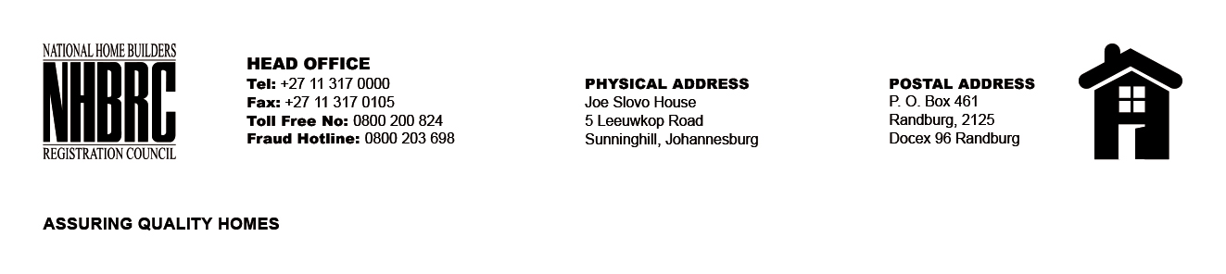

BID NUMBER: NHBRC 06/2023
CLOSING DATE: 26 MARCH 2024 @ 11H00

BID DESCRIPTION: REQUEST FOR PROPOSALS: APPOINTMENT OF A SUITABLE SERVICE PROVIDER TO INSTALL & MAINTAIN THE VIDEO CONFERENCE SYSTEM FOR A PERIOD OF THREE (3) YEARS.
RE-ADVERT

NO. | NAME OF BIDDER | PRICE
1. | Cloudsol Communications (Pty) Ltd | R4 530 316, 98
2. | Warico Trading (Pty) Ltd T/A NCX | R6 769 947,81
3. | Ubuntu Technology (Pty) Ltd | R10 836 697,68
TOTAL: 3

