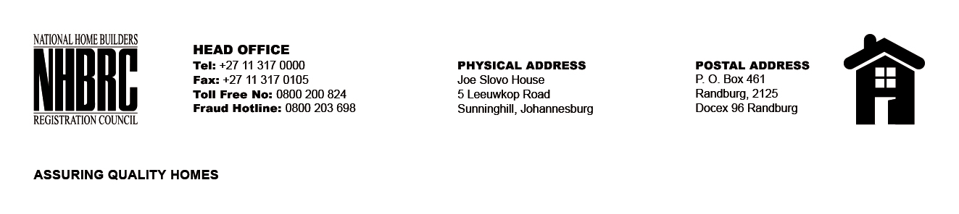

BID NUMBER: NHBRC 13/2023
CLOSING DATE: 26 MARCH 2024 @ 11H00

BID DESCRIPTION: REQUEST FOR PROPOSALS: APPOINTMENT OF A SERVICE PROVIDER TO DEVELOP AND HOST WEB BASE VENDOR LISTING FOR A PERIOD OF THREE (3) YEARS.

NO. | NAME OF BIDDER | PRICE
1. | CS Contrast Technologies | R21 367 000,00
2. | PaluCode (Pty) Ltd | R659 006,00
3. | Pulego Technologies | R4 005 680,00
4. | Techex Digital Solutions | R3 950 250,00
5. | eSoftware Solutions | R4 776 249,85
6. | MySmart Cash | R2 618 600,00
7. | Hash Topic (Pty) Ltd | R1 868 750,00
8. | African Proficient Software | R4 200 000,00
9. | PTP Integrated (Pty) Ltd | R3 724 719,07
TOTAL: 9

