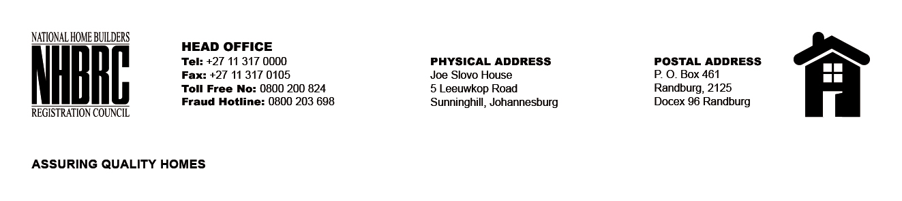

BID NUMBER: NHBRC 11/2023
CLOSING DATE: 06 February 2024 @ 11H00

BID DESCRIPTION: REQUEST FOR PROPOSALS: ESTABLISHMENT OF PANEL OF SERVICE PROVIDERS TO PERFORM RESIDENTIAL INSPECTORATE SERVICES ON BEHALF OF NHBRC FOR A PERIOD OF FIVE (5) YEARS.
PORT ELIZABETH (EC)

NO. | NAME OF BIDDER
1. | UBUNYE NGAMANDLA TRADING ENTERPRISE
2. | LILITHA PROJECT MANAGERS CC
3. | KRMS ARCHITECTS
4. | LETHOKUHLE CIVILS (PTY) LTD
5. | R & G TURNICEY SOLUTIONS (PTY) LTD
6. | V3 CONSULTING ENGINEERS
7. | SMAY INVESTMENTS (PTY) LTD
8. | LELOKO LA BATHO
9. | EXILITE 349 CC
10. | MZANSI AFRICA CIVILS
11. | DAKAR CONSTRUCTION SERVICES
12. | MGIBA CONSULTING
13. | MBSA CONSULTING CC
14. | KATEMO GENERAL TRADING
15. | SERETO VENTURES CC
16. | IMBUMBA INVESTMENTS
17. | UNDASA PROJECT PARTNERS (PTY) LTD
18. | JTP CONSORTIUM (PTY) LTD
19. | MOKWADI ENGINEERS AND CONSTRUCTION CC
20. | HLUMANTOMBAZANA CIVIL & CONSTRUCTION CC
21. | CALCULUS ZINATHI
22. | GILGAL DEVELOPMENT CONSULTING ENGINEERS AND PROJECT MANAGERS
23. | E-SQUARE ENGINEERING (PTY) LTD
24. | MJT CONSULTING ENGINEERS 01 (PTY) LTD
25. | THEMANE MANAGEMENT CONSULTING (PTY) LTD
26. | ENDINAKO PROJECTS
27. | ZIMINGO
28. | WALKING TALL TRADING AND PROJECTS 79
29. | AKWAKHE
TOTAL: 29

