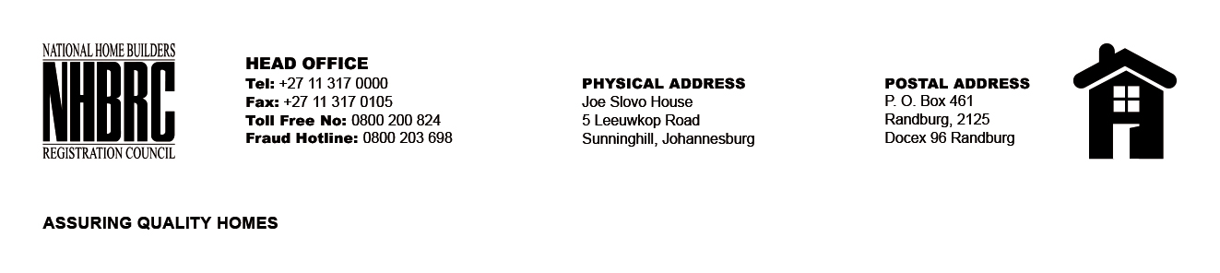

BID NUMBER: NHBRC 01/2024
CLOSING DATE: 25 July 2024 @ 11H00

BID DESCRIPTION: REQUEST FOR PROPOSALS: APPOINTMENT OF A SERVICE PROVIDER TO PROVIDE SUITABLE OFFICE ACCOMMODATION AND PARKING FACILITIES FOR DURBAN OFFICE FOR A LEASE PERIOD OF FIVE (05) YEARS.

DURBAN-KZN

NO. | NAME OF BIDDER | PRICE
1. | DELTA PROPERTIES FUND LIMITED | R13 973 406.69
2. | SERITOMART | R17 340 203.44
TOTAL: 02

