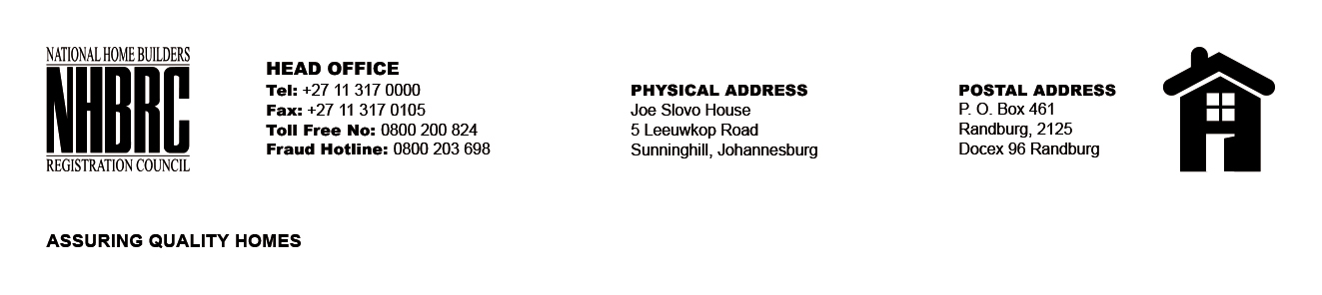

BID NUMBER: NHBRC 01/2024
CLOSING DATE: 26 JUNE 2024 @ 11H00

BID DESCRIPTION: REQUEST FOR PROPOSALS: APPOINTMENT OF A SERVICE PROVIDER TO PROVIDE SUITABLE OFFICE ACCOMMODATION AND PARKING FACILITIES FOR THE KLERKSDORP OFFICE FOR A LEASE PERIOD OF FIVE (05) YEARS.

NW KLERKSDORP OFFICE

NO. | NAME OF BIDDER | PRICE
1. | SKG AFRICA (PTY) LTD | R2 873 220,11
2. | SUREGO INVESTMENT | R2 797 157,51
TOTAL: 02

