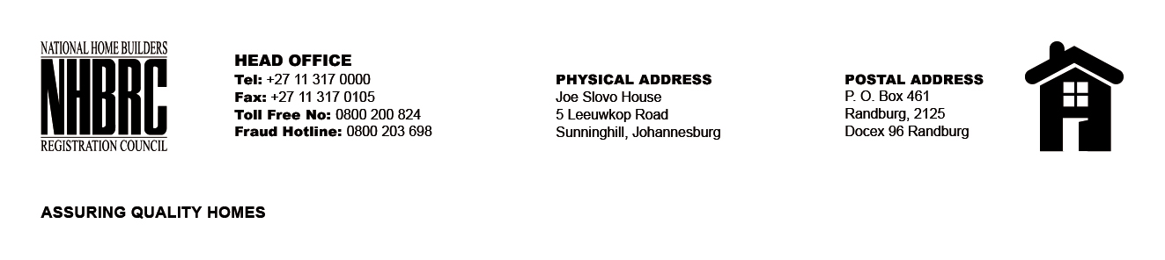

OPENING REGISTER

BID NUMBER : NHBRC 01/2024_NW_Mahikeng Office
CLOSING DATE : 25 July 2024 @ 11h00

BID DESCRIPTION: REQUEST FOR PROPOSALS: APPOINTMENT OF A SERVICE PROVIDER TO PROVIDE SUITABLE OFFICE ACCOMMODATION AND PARKING FACILITIES FOR THE MAHIKENG OFFICE FOR A PERIOD OF FIVE (05) YEARS.

NO. | NAME OF BIDDERS | PRICE (INCL. VAT)
1. | Columbia Falls Properties 80 (Pty) Ltd | R2,412,573.06
TOTAL BIDS RECEIVED |  | 01

