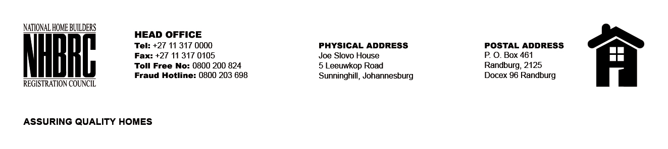

BID NUMBER: NHBRC 01/2024
CLOSING DATE: 26 July 2024 @ 11H00

BID DESCRIPTION: REQUEST FOR PROPOSALS: APPOINTMENT OF A SERVICE PROVIDER TO PROVIDE SUITABLE OFFICE ACCOMMODATION AND PARKING FACILITIES FOR NEWCASTLE OFFICE FOR A LEASE PERIOD OF FIVE (05) YEARS.

NEWCASTLE-KZN

NO. | NAME OF BIDDER | PRICE
1. | COOL BLUES TRADING (PTY) LTD | R2 437 193.25
2. | MANTOMPHI (PTY) LTD | R3 663 222.91
TOTAL: 02

