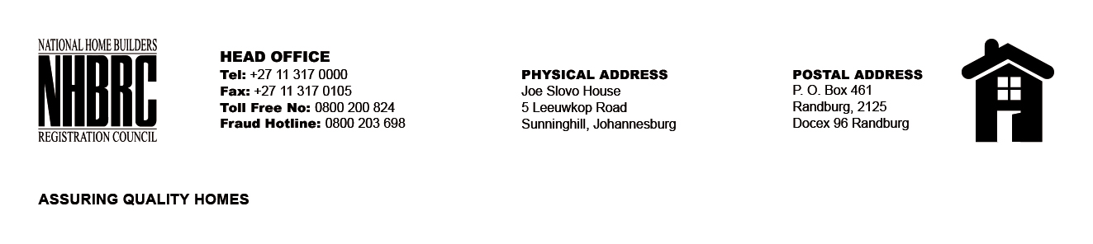

BID NUMBER: NHBRC 01/2024
CLOSING DATE: 26 JUNE 2024 @ 11H00

BID DESCRIPTION: REQUEST FOR PROPOSALS: APPOINTMENT OF A SERVICE PROVIDER TO PROVIDE SUITABLE OFFICE ACCOMMODATION AND PARKING FACILITIES FOR TSHWANE OFFICE FOR A LEASE PERIOD OF FIVE (05) YEARS.

GP-TSHWANE OFFICE

NO. | NAME OF BIDDER | PRICE
1. | SKG AFRICA (Pty) Ltd | R13 028 936, 91
TOTAL: 01

