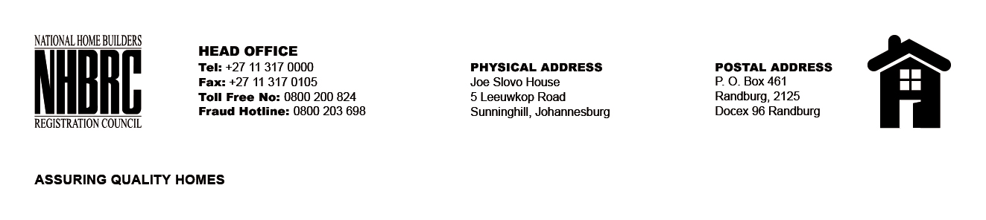

BID NUMBER: NHBRC 02/2024
CLOSING DATE: 07 AUGUST 2024 @ 11H00

BID DESCRIPTION: REQUEST FOR PROPOSALS: APPOINTMENT OF A SUITABLE SERVICE
PROVIDER TO PROVIDE HYGIENE SERVICES AND SUPPLY HYGIENE
CONSUMABLES TO THE NHBRC (HEAD OFFICE - SUNNINGHILL AND ERIC
MOLOBI - SOSHANGUVE) FOR A PERIOD OF THREE (03) YEARS.

GAUTENG

NO. | NAME OF BIDDER | PRICE
1. | MASANA HYGIENE SERVICES (PTY) LTD | R4 870 026, 05
2. | GLAMARO (PTY) LTD | R8 483 593,71
3. | KGATISI TRADING CC | R6 963 096, 08
4. | ENVIRO’MENTAL HYGIENE | R4 265 906, 73
5. | TRANDYLAB TRADING (PTY) LTD | R800 681, 72
6. | LEGOBOLE ENTERPRISES (PTY) LTD | R1 949 141, 03
7. | NELEDZI CLEANING SERVICES (PTY) LTD | R6 996 723, 80
8. | MJ INNOVATIVE SOLUTIONS | R4 223 512, 22
9. | KEMPSTON CLEANING SOLUTIONS | R3 186 325,62
10. | WPM CONSULTING (PTY) LTD | R4 547 721, 84
11. | 5 STAR CLEANING SERVICES | R4 736 698, 96
12. | KAMESO TOTAL HYGIENE SERVICES | R4 627 719, 74
13. | BLUEBERRY HYGIENE CLEANING SERVICES | R17 061 771, 29
14. | ADVANTAGE SECURITY & CLEANING SERVICES CC | R2 468 360, 52
15. | NTSEBE PROJECTS | R3 561 994, 08
16. | MONABO HYGIENE SERVICES | R7 639 526, 41
17. | SANITECH | R4 791 664, 46
18. | NOZINGA GROUP T/A IFM SOLUTIONS | R4 412 722,40
19. | WEALTH GROUP CLEANING SERVICES | R15 439 055, 90
20. | JECON PROJECTS | R3 280 077, 60
21. | NOTLO PEBETSE | R4 689 032,46
22. | POWER FULL CLEANING & PROJETS (PTY) LTD | R5 650 186, 39
23. | MEDILAC GROUP (PTY) LTD (SUNNINGHILL)  (SOSHANGUVE) | R5 420 830, 47  R1 208 909, 15
24. | THEMBANE CLEANING SERVICES CC (SUNNINGHILL)  (SOSHANGUVE) | R2 576 842, 45  R1 034 245, 00
25. | BAFITHLILE INTELLIGENT UNIT (PTY) LTD | R10 850 759, 53
26. | ZWOLUGA CIVIL & TRADING JV PRIMMEST | R1 807 998, 00
27. | DELTA CLEANING & HYGIENE (SUNNINGHILL)  (SOSHANGUVE) | R3 330 663, 50  R2 929 106, 79
28. | RAMAATHLAMA & MATJA GROUP(SUNNINGHILL)  (SOSHANGUVE) | R 3 063 082, 49  R1 109 546, 54
29. | KUSILE FACILITIES MANAGEMENT | R5 167 573, 94
30. | DREAMFINDERS TRADING & PROJECT 562 | R704 894, 79
31. | PROSPER BLINDS (PTY) LTD (SUNNINGHILL)  (SOSHANGUVE) | R12 562 966, 51  R2 354 808, 43
TOTAL: 31

