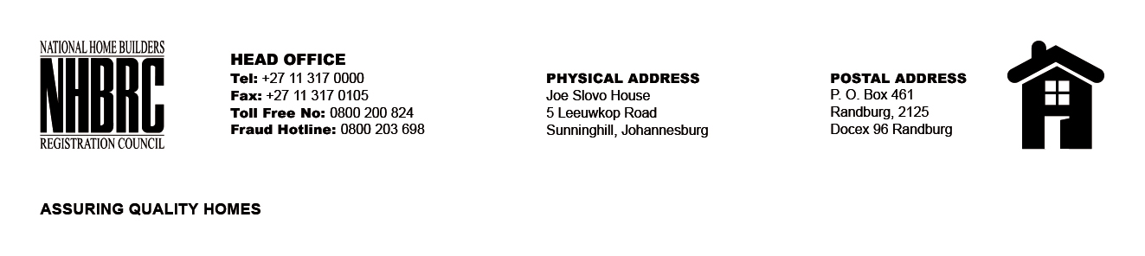

BID NUMBER: NHBRC 03/2024
CLOSING DATE: 03 SEPTEMBER 2024 @ 11H00

BID DESCRIPTION: REQUEST FOR PROPOSALS: APPOINTMENT OF A SUITABLE SERVICE PROVIDER TO PROVIDE EMPLOYEE WELLNESS PROGRAM (EWP) TO THE NHBRC FOR A PERIOD OF FIVE (05) YEARS.

NO. | NAME OF BIDDER | PRICE
1. | WONKE WELLNESS SERVICES | R7 369 772.00
2. | THERAPY ON THE GO | R27 643 107.20
3. | LIFE HEALTH SOLUTIONS (PTY) LTD | R1 771 501.41
4. | LYRA SOUTHERN SOLUTIONS (PTY) LTD | R1 194 747.91
5. | DR BARBARA CAWOOD INC | R60 979 094.13
6. | LARONA CONSULTING (PTY) LTD | R2 184 397.00
7. | AGILITY HEALTH (PTY) LTD | N/A
TOTAL: 07

