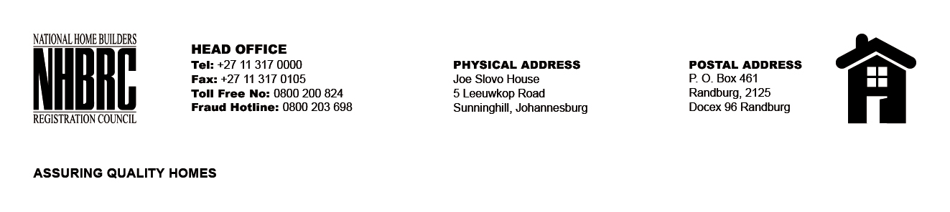

BID NUMBER: NHBRC 01/2024 EC_EAST LONDON
CLOSING DATE: 27 SEPTEMBER 2024 @ 11H00

BID DESCRIPTION: REQUEST FOR PROPOSAL: APPOINTMENT OF A SERVICE PROVIDER TO PROVIDE SUITABLE OFFICE ACCOMMODATION AND PARKING FACILITIES FOR EAST LONDON OFFICE FOR A LEASE PERIOD OF FIVE (05) YEARS.

NO. | NAME OF BIDDER | PRICE
1. | CAPSTONE 598 9PTY) LTD | R3 380 744. 45
2. | SKG AFRICA (PTY) LTD | R4 124 567.69
TOTAL: 02

