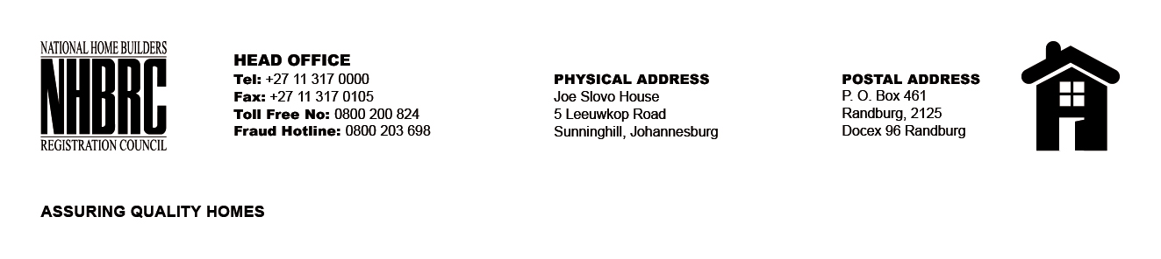

OPENING REGISTER

BID NUMBER : NHBRC 01/2024_KZN_Newcastle Office Lease Re-advert
CLOSING DATE : 27 September 2024 @ 11h00

BID DESCRIPTION: REQUEST FOR PROPOSALS: APPOINTMENT OF A SERVICE PROVIDER TO PROVIDE SUITABLE OFFICE ACCOMMODATION AND PARKING FACILITIES FOR THE NEWCASTLE OFFICE FOR A PERIOD OF FIVE (05) YEARS.

NO. | NAME OF BIDDERS | PRICE (INCL. VAT)
1. | Newcastle Office Park (Pty) Ltd | R2,374,986.18
2. | Mantomphi (Pty) Ltd | R4,663,222.91
3. | Sub 4 of Lot 509 (Pty) Ltd | R3,389,881.60
TOTAL BIDS RECEIVED |  | 03

